
HiPpY KiDs At Home

Hippy Kids is an established Childcare business run by Beccy and Charlie Bourne. Our business started in 2007 as a Childminding business, and we expanded to open our Playschool in January 2024. Our website is www.hippykids.co.uk. We were last inspected by OFSTED in April 2026. We are delighted with the report card, you can read it here: Hippy Kids Playschool - Open - Find an Inspection Report - Ofsted.

Beccy began childminding in 2007 when becoming a parent and Charlie joined in the business in 2009. We live in South Portslade with our three daughters. Our eldest daughter is now a fully qualified member of our team so we truly have a family run business.

Whilst children are in our care, they will participate in lots of child led activities as well as celebrating nature and the seasons. We have a beautiful shady forest garden, and Charlie is a qualified forest school leader. We have mud kitchens, a fire circle and tree houses. We encourage lots of free play and exploration. We believe that children learn best through play.

We run a messy playgroup at the local community centre on a Tuesday morning. Hippy Kids Playgroup is a sensory journey where we provide, messy play, arts around a different theme each week. Parents are invited to come along and take part.

We also make regular trips to the local nursing home with the children and have weekly yoga sessions with a qualified teacher.

We love to take the children to many of our great surrounding parks. We also sometimes take the children to beaches and other local places of interest.

We provide vegetarian and vegan meal options each day and are happy to discuss any dietary needs. All our meals are homemade by Charlie with love and care. We think meal times are a great opportunity for communication and building relationships.

We use a software app called Famly to communicate with parents and record child’s development. Your child will be assigned a keyworker. It is the keyworker’s responsibility to ensure that regular observations are made of the child, although due to our close relationships with the children this often means that all members of our team organically make observations during our time together.

We have a team of highly experienced and qualified Early Years Educators. We pride ourselves on our high retention of staff and are a very happy team. We are accredited Living Wage Employers.

We are able to offer government funding for all children who are eligible under the government scheme. Please refer to our funding sheet for information on how to use this funding at Hippy Kids.

We offer lots of individual attention to the children and provide ‘home from home’ care, this appeals to parents as they know the child has all the comforts and security of a home as well as having other children to play with. We always aim to provide an excellent partnership with parents and provide the next best thing to a home environment. We love to welcome children to our family and can assure you that your child will be treated as one of our own.

We encourage children to feel secure, confident, and happy. We offer children compassion, understanding and patience to help them settle and become secure members of our Hippy Kids family.

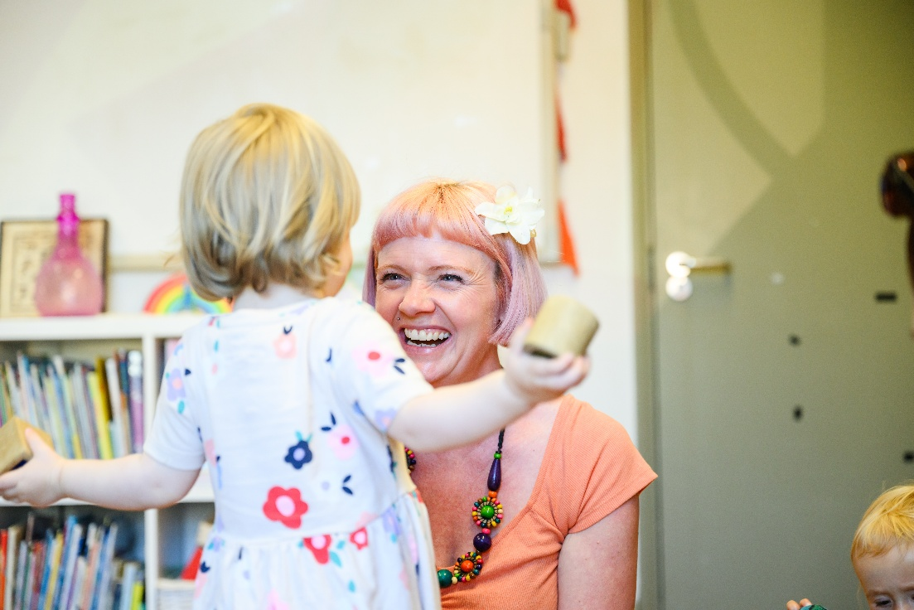

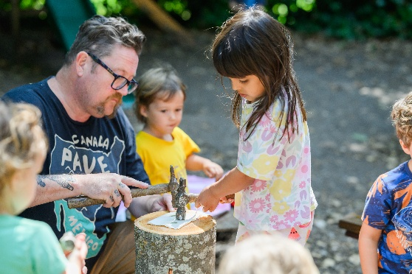

Safety

Children in our care are supervised within our sight and/or hearing at all times. The level of supervision will depend on the activity being undertaken, and the age and ability of each child.

We adhere to ratios at all times and regularly review risk assessments.
We have appropriate insurance policies and all our staff are trained in Paediatric first aid and DBS checked. We have a stringent recruitment procedure and adhere to requirements of the EYFS.

All our staff are fully trained in safer sleeping and safe eating procedures, we regularly attend safeguarding training and supervision meetings.

We have a detailed safeguarding policy that is available to all parents upon request.

We regularly undertake evacuation drills to ensure that all children and staff are aware of emergency procedures.

We have parental permission forms for application of sun cream, routine outings and taking photographs. We ask that all parents/carers sign these if they are happy to do so.
Accidents

If a child arrives with an existing injury then it is our duty to make a record of the injury, we will ask the parent to explain how the injury happened. A note will then be made on the child’s profile on our Famly app.

If the child has an accident whilst they are in our care we will record this in our accident book and a copy will be sent to parents via the app. Unfortunately accidents do happen and it is our policy to be transparent about this and inform you of any incident however small.

If the accident is serious we will immediately contact the parents and make arrangements to meet at the local hospital
Hygiene

We are aware of the importance of hygiene and have various procedures in place to ensure the cleanliness of our settings and the children we look after.
Our settings are cleaned on a regular basis and all toys and equipment are washed after every use when appropriate. We have revised our cleaning procedures and can confirm that they are in line with national recommendations since COVID 19.
We ask parents to supply us with a change of clothes to use in the event of any accidents (messy play, toilet training, exploding nappies etc!).
We make sure that hands are washed for mealtimes and after visits to the toilet.

If we find that your child has head lice we will ask you to administer headlice treatment. We ask that you also treat other family members and change bedding accordingly. It is necessary to repeat the lice treatment after 7 days to break the life cycle of the eggs. If you do not wish to administer treatment then we may ask for you to collect your child to prevent contamination and spread of infestation.

Sickness

We will not undertake the care of sick children. This is not only to prevent the illness being passed on to others in our care, but also to protect the child that is ill. We believe that most sick children would prefer to be at home with their parent who is able to provide them with the one to one attention they need.
Please do not administer Calpol before dropping your child to Hippy Kids. If your child becomes ill or has a high temperature, we will call you to come and collect them.

We do not accept children who have had Calpol in the last 24 hours as this can mask the symptoms of a serious illness.

We will not administer medication to a child without written permission from the parent via the app. The medication must be prescribed for the child and be in the original packaging.

If your child has more than one ‘loose poo’ (diarrhoea) whilst attending a session with us then you will be asked to come and collect them.

We have thermometers that staff members can use for checking your child’s temperature and you will be asked to come and collect them if they have a fever.
As responsible childminders, we do not take care of children who are infectious, have had a fever within the last 24 hours or have vomited or had diarrhoea within the last 48 hours. We will, however, look after children with mild illnesses such as colds etc. providing they are not too ill to participate in a normal day's activities. Please note that we reserve the right to judge a child’s wellness to attend regardless of NHS guidance (i.e exclusion periods etc.) as we feel a poorly child will simply not thrive within the setting.

If your child has an illness or condition that has not been listed here, or a member of staff is unsure of our policies/procedures concerning a situation then they will seek advice from a manager.

Behaviour Management

We aim to provide an environment where children feel secure, safe and understand boundaries. We believe that children who know and understand what their rules and boundaries are will feel happier and are therefore less likely to exhibit unwanted behaviours.
We are aware of continuity of care and will discuss all aspects of behaviour management with the parents.
We will never use, or threaten to use, physical punishment in any form. The minimum amount of physical restraint will be used only if a child is at risk of harming themselves or others.
Any concerning behaviour will be recorded and parents advised.
Positive behaviour is rewarded by verbal praise and congratulating them in the presence of their parents/carers. We use positive behaviour management by encouraging respect for others, setting realistic boundaries and using encouragement instead of orders and instruction. We aim to be consistent and build children's self-esteem through praise, appreciation and attention.

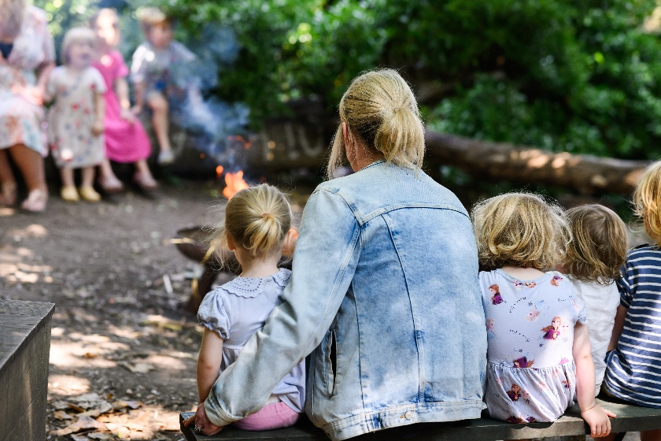

Collection of Children

Our normal procedure is to release the child only to his/her parents/carer or someone else who the parents designate.

If someone other than the parents is to collect a child, we ask the parent to notify us. If the child is not old enough to recognise that person and we do not know them, we might ask for the parent to send us a photo so we can identify them. We might also ask you to add a password to the app to enable the person to collect the child.

Procedure for Uncollected Children

If parents are going to be late for any reason, we ask them to inform us by phone or text at their earliest convenience. We work within our ratios and are unable to go above our numbers for safety reasons. We are not permitted to use our Playschool space after 6pm.

If the parent has not arrived to collect the child within 15 minutes of collection time, and we have not been notified of lateness, we will call them immediately.

We have late collection fee of £50 per child. Repeated late collection is unacceptable and may result in termination of your contract. We do understand that sometimes lateness is unavoidable and allowances will be made in exceptional circumstances.

If we are unable to contact the parent on their given numbers we will wait 30 minutes after collection time. If they have made no contact within this time period we will refer to the emergency contact list and contact the emergency people listed in order to arrange for them to collect the child. If we are unable to contact any of the emergency people listed then we will contact the social services 1 hour after collection was due to take place.

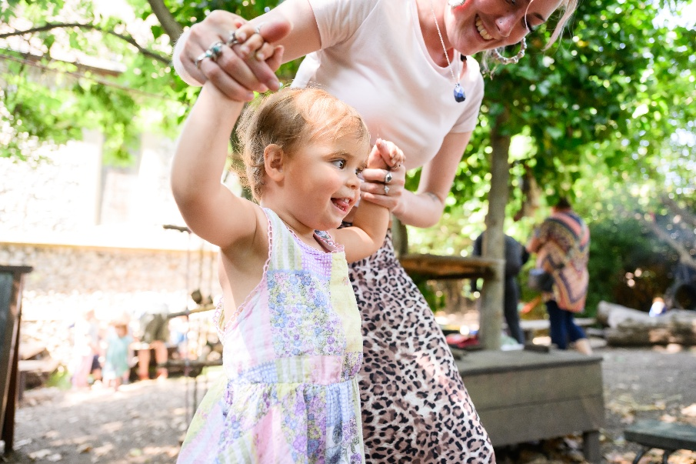
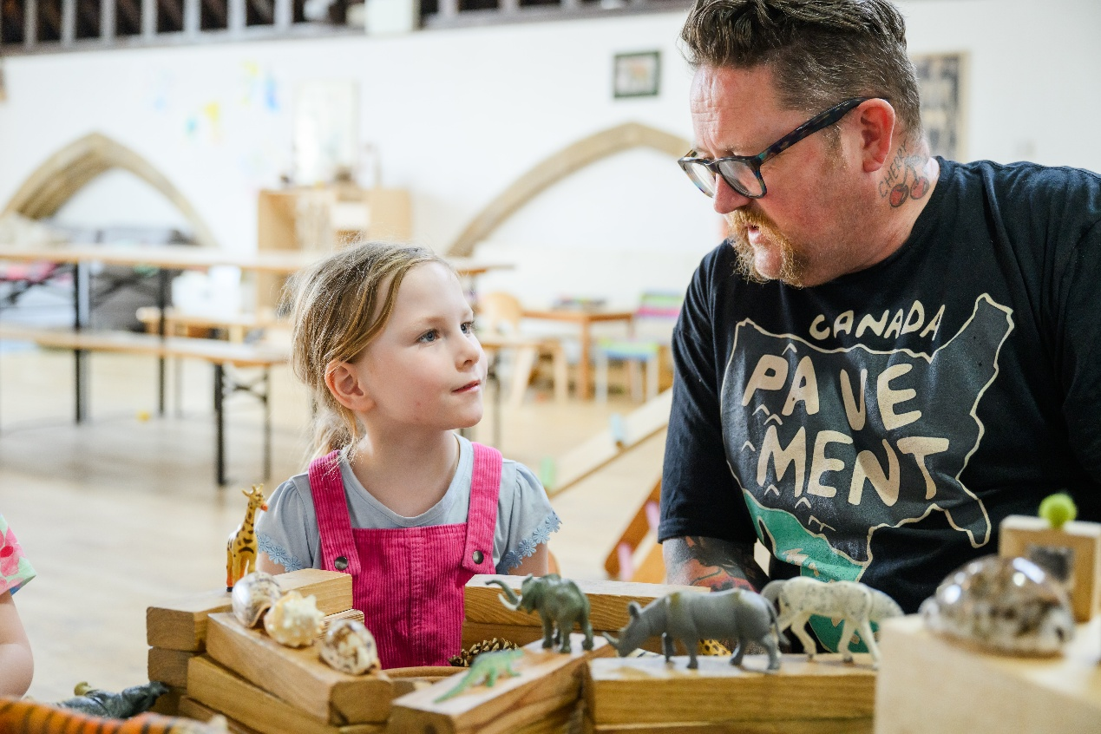

Outdoor Play

We ask parents to provide children each day with a bag containing a coat/jacket, wellies (depending on season) and a change of clothes

We enjoy being outside at both settings whatever the weather so please ensure you provide warm and waterproof clothing (including for babies and non walkers) every day. Each child has a coat peg and a bag to store their belongings.

We apply sun cream if appropriate and ask for your permission to do so. We dress the children in high visibility jackets when we are out to help everyone stay safe.

We ask for parents permission for outings at the beginning of our contract but will still let them know if we have planned a special trip. We always risk assess our outings individually and consider more stringent ratios if we feel it is necessary.

Equality, Diversity & Inclusion

It is our duty to provide an environment free from prejudice in any form. We believe that children have a right to feel valued, develop a positive self image and be free from discrimination.
We show no discrimination or preference for any child irrespective of race, religion, gender, age, ability, additional needs or social background. We will challenge any discriminatory remarks, inappropriate attitudes and behaviour from both children and adults, including parents.
Each child in our care is treated with equal concern and encouraged to develop their own potential and to grow as individuals with different needs.
We provide play resources and books that give a balanced view and appreciation of the diversity of our multi-racial society.
We liaise with parents/carers to ensure that appropriate information is obtained to enable us to provide suitable care according to their stage of development, gender, ethnicity, special educational needs, home language and any special or specific needs.
Children have special educational needs if they have a learning difficulty, which calls for special educational provision to be made for them.

The keyworker/SENCO liaises with the SENCO and PRESENS where appropriate, to co-ordinate an Individual Education Plan (IEP) for children with SEN in their care. IEP’s will be working documents that are regularly reviewed, evaluated and updated at least twice per year.

Complaints regarding SEN provision should initially be discussed with the manager concerned. If no agreement can be reached, the complaint should be forwarded to the relevant development officer, in writing, at Brighton and Hove City Council, CEYC, 3rd Floor, Kings House, Grand Avenue, Hove, BN3 2LS, who will endeavour to resolve the problem. They will seek advice from the Area SENCO as necessary.

Independent advice and support is available from the Partnerships with Parents Service, Amaze, telephone 01273 772289.

The Disability Rights Commission (tel: 08457 622 633) provides a range of information and guidance on the Disability Discrimination Act. This organisation would be able to advise if the concern relates to an issue of the possible discrimination of a disabled child.

Safeguarding Children Policy
As registered Childminders we have a duty under the Children’s Act to refer any concerns we may have about the welfare of a child in our care.
We are committed to creating an environment in which children are safe from abuse. Both ourselves and anyone else who spends regular time with the children whilst in our care, has undergone an enhanced criminal record check and has been approved as suitable to work with children. All our staff are fully aware of the safeguarding policies and procedures in place and are given a copy of our policies when commencing employment.
We ask for your permission to take photos of your children. If you would prefer us not to do so then we will ensure that all members of staff are aware of your wishes.
We all regularly attend safeguarding courses and we are aware of behavioural and physical signs of abuse. We have read and understood the Government’s statutory guidance ‘Working Together to Safeguard Children’. This publication, as well as other local information, is available on the Brighton and Hove LSCB website www.brightonandhovelscb.org.uk. All staff members are aware of The Prevent Duty which became law in 2015. This is a duty on all schools and registered early years providers to have due regard to preventing people being drawn into terrorism. We are also aware of FGM (Female Genital Mutilation) and have been trained in how to recognise the signs and symptoms of such abuse.
Should we have any concerns regarding a child's welfare then we will discuss this with the parents. We may also consult the Brighton and Hove Childminding Team, NSPCC or social services for confidential advice.
If we suspect that abuse may be taking place then our first concern will be that of the child and we will immediately inform the Authorities and the Social Services. We will report any concerns to Brighton and Hove Front Door For Families on 01273 290400, FrontDoorForFamilies@brighton-hove.gcsx.gov.uk.
If any allegations of abuse are made about ourselves or other people who have access to a child whilst in our care then we will inform the parent of the child, OFSTED, and possibly the Police of such allegations immediately. We would liaise with the above-mentioned Advice Contact and Assessment service who usually investigate such allegations. We would also ask the parent to remove the child from our care until the situation is resolved.
We may also seek the advice of the Local Authority Designated Officer (LADO).
We will ensure that utmost confidentiality is maintained at all times.

Useful Telephone Numbers:
Brighton and Hove Front Door For Families : 01273 290400
Police Child Protection Team 01273 685539
NSPCC 24 Hour Help Line 0800 800 500
Childline 0800 1111
Parentline 0808 800 2222
FGM Helpline: 0800 028 3550
Social Services:

mash@westsussex.gcsx.gov.uk
Tel:01403 229900

Single Point of Advice (SPOA) team Phone: 01323 464222

OFSTED 0300 123 1231 www.ofsted.gov.uk

Confidentiality

We respect the need for confidentiality and therefore keep all written information regarding children and their families in individual files. Only we can access these files and information is kept confidential. The only exception to this rule is our lists of emergency contact numbers, these must be accessible for safety reasons.

Any records we keep regarding contact with parents are honest, reliable and stored in the confidential file. Information obtained is in the child’s best interest and is used to provide high quality childcare.

Information will only be shared in the event that a child protection issue arises.

We aim to provide a trusting relationship with parents and prove our reliability in keeping their details and information confidential.
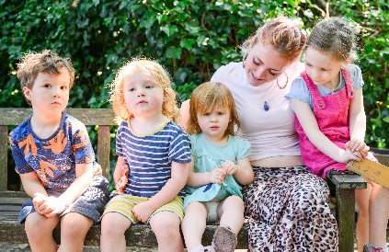

GDPR Policy

In order to comply with the conditions of the General Data Protection Regulation (GDPR) and the Information Commissioners office (ICO), we are required to state what data we collect, why we collect your personal data, what it is used for and who we will share it with. We also need to inform you how long we must keep it for and why.
We will keep any data confidential and only share when consent has been obtained except in cases of safeguarding and welfare of the child where we are obligated to share.

What data do we collect?
Name, address and contact details of parent/s or person with parental responsibility
Name and contact details of emergency contacts
Name and date of birth of your child/ren
Details of any medical conditions/medication
Details of child’s GP/Health visitor
Parents NI number
Childs proof of age
Photos of children
Childs name on artwork

Why do we collect your data?
In order to process invoices
To fill out medication forms
To keep records of your child/rens development and observations
Record details and observations for your child’s learning journals
To record details of any accidents/incidents whilst in our care

How we will store your data?
Children’s records are stored in their files in a locked filing cabinet/securely on a separate password protected hard-drive
Digital photos are stored on a secured cloud-based storage or password protected hard-drive.
Learning journals are kept in a locked filing cabinet
Artwork and pictures displayed in the setting
To prove eligibility for funding we need parents NI number and child’s birth certificate/passport.
To fill out funding (EYFE) contracts
To carry out 2-year progress check
To identify a child’s belongings

Who will we share your data with?
We will only share the data where it is our obligation to under legislation e.g. Ofsted/social services/local authority.
Unless it is a case of child protection we will always obtain your permission to share this data

How long will we keep your data?
We are required to keep registers of children’s attendance until they are 21 years 3 months old
We are required to keep Accident/incident reports until children are aged 21 years 3 months
We are advised to keep contracts and children’s record forms for 2 years
Childs learning development records leave with the child when they are no longer in our care.
A copy of the child’s 2-year progress check must be kept until the child is 21 years and 3 months old.
Photographs will be deleted when the child leaves the setting unless permission is agreed.
Any photographs used for advertising will also be subject to separate consent.

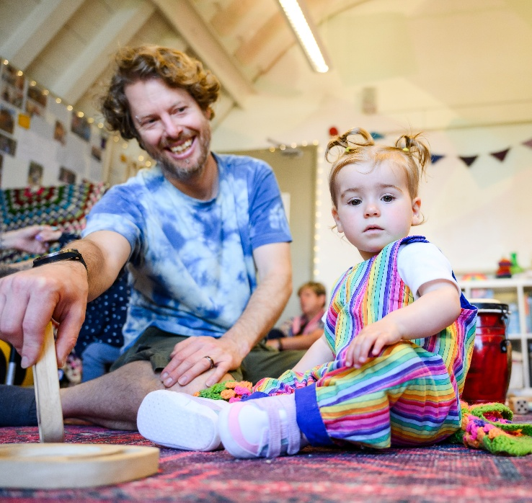

Staff Policy

We aim to provide a safe, clean and caring environment for children to be. We are proud of the fact that all our staff members are aspiring role models for the children and offer care in a very natural and nurturing way. We will not tolerate use of inappropriate language or behaviour in our setting and all staff will be reprimanded according.

All our staff members have been DBS checked, first aid trained and undergo supervisions, training and are reflective in their practices.

We have a very strict No smoking/vaping policy. Smoking/vaping is not permitted inside or directly outside our settings including our gardens. We expect all staff to adhere to these rules.

Partnership With Parents

We pride ourselves on our excellent, longstanding partnerships with parents. We have been a part of the Portslade community for years and love bumping into families and hearing updates of children who have attended our settings.

When your child begins their journey at Hippy Kids we understand that parents will sometimes feel anxious and aim to try our very best to provide as much reassurance and updates as possible. We use the Famly App to communicate and encourage both parents to each have a login for this. We share photos of what the children get up to and observations of their development. We use this platform to share news of closure days and other important news.

We reply promptly to parents messages when they check in. We encourage parents to share news with us using the app, the children love seeing photos that parents have sent over and telling us about their weekends.

We try to allow enough time at drop off and pick up to provide enough feedback to parents. If you have concerns or questions about a matter that requires more time then please send us a message using the App. It is likely that staff members will have a responsibility for other children at busy times of the day so please have reasonable expectations for our response time. It is preferable to make an appointment with your child’s key person or a manager rather than discussing concerns at the door. Please bear in mind that we do not always respond to messages outside of our working hours. It is important for us to maintain a work/life balance.

Your views and what you have to say are very important to us and deserves to be heard confidentially. There are lots of options, we can arrange a face to face meeting, a telephone call or often explain things in a message using the app if time is short.

Please respect our setting’s peaceful values and ethos, our caring and nurturing staff deserve to be treated in a kind and friendly manner. Hippy Kids is a safe space and we will not tolerate irresponsible behaviours such as raised voices, spreading of rumours and defamation of character (in person or on social media).

Your children are at the very heart of everything we do and it is expected that every parent provides cooperation and support to enable us to nurture them and help them grow.

Allegations and Complaints Procedure

We aim to provide an excellent service for parents and their children; however, we do understand that sometimes there may be issues that require discussion.
If parents have any concerns regarding our service, however minor, we ask them to contact us. Most concerns can be resolved at a very early stage, often with a simple explanation.
We will listen to parents concerns and respond as honestly as we can, hopefully resolving the matter and putting them at ease. We are required to deal with any complaint within a period of 28 days.
It is a legal requirement to keep a complaints record and that the record of any complaint must be kept for 3 years.

Ofsted will be notified of any complaints relating to the requirements of the EYFS or the Childcare Register and any complaints relating to safeguarding might also be reported to the Local Safeguarding Children Board (LSCB). Depending on the nature of the complaint, it will be investigated internally or passed to Ofsted and / or the LSCB to investigate.

OFSTED
0300 123 1231
www.ofsted.gov.uk

City Early Years & Childcare
Childcare Workforce Development Team
Brighton Town Hall
Bartholomew Square
Brighton BN1 1JA 01273 290000

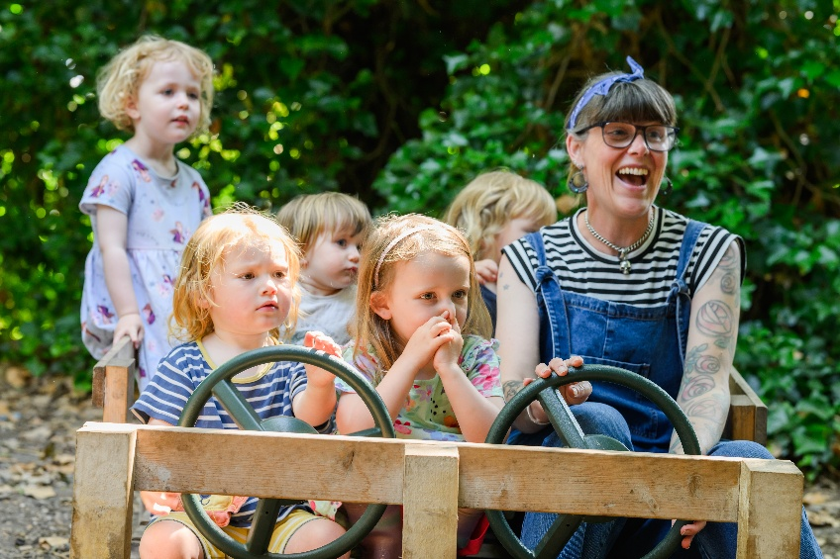
Payment

Invoices are emailed over at the end of each month for the following month. Payment is due by bank transfer, childcare vouchers or cash by the 1st of each month. We also accept a range of childcare vouchers and you can also pay us through the tax free childcare scheme.

We are open all year round but always close for 2 weeks at Christmas and 2 weeks in the Summer.

Please note that if your payment is later than 5 days late you will incur a late payment charge of £25 and then £10 per day thereafter.

All prices include nappies, snacks, wipes and outings. Please see our separate funded hours policy for details on how to use the Government funded hours.

First Settling in session is free

Regular Prebooked hours £7 per hour, minimum session 3 hours

Pay as you Go (subject to availability) – £7.50 per hour for children under school age

Pay as you Go includes any hours that are outside of our arranged contract
£3 per meal for under 3’s

£4 per meal for over 3’s

Playgroup Charge – applicable to all those who attend on a Tuesday morning - £3

Lateness – We have a late collection charge of £50 per child. Repeated lateness is unacceptable and will result in the termination of your contract.

Child Sickness, Child Holiday, Bank Holiday – Full Fee Payable
Hippy Kids Holiday Time – No Fee Payable
Closure due to severe weather conditions (subject to full risk assessment) – Full Fee Payable

Invoices are payable one month in advance
Term Time contracts are available upon request
The First settling in session is free.

Government Funded Hours Policy

All 3 and 4 year olds can receive 15 EYFE hours per week, some 3 and 4 year olds are eligible for 30 hours. This is the ‘working parent entitlement’.
Younger children (from the age of 9 months) can also access the 30 hour working parent entitlement if their parent or parents are working and meet the governments eligibility criteria. Go to the Best Start in Life website for more information.
At Hippy Kids, we offer funded hours as follows subject to availability:
OPTION 1: Standalone Offer
- A) 15 Funded hours a week
You can use all or some of your funded hours with NO FEE payable in our limited 3 hour sessions TERM TIME ONLY.
The free 3 hour sessions we offer are 1.30pm to 4.30pm Monday to Friday subject to availability.

- B) Extended Funded hours (30 hours a week)
At Hippy Kids, we provide the extended hours as a stretched offer equating to 23.75 hours a week if you are using Option 1. Subject to availability.
You can use all or some of your funded hours with NO FEE payable in our 4.75 hour sessions ALL YEAR ROUND. These free sessions are from 12.15 to 5pm Monday to Friday.
You can choose to buy non-funded hours and meals before and during these session times. Prearranged hours would be charged at £7 per hour and the cost of lunch and dinner is £4 per meal.
Snacks, drinks, sun cream, trips and activities are included. Messy playgroup will be charged at £3 on Tuesday mornings when/if your child is booked in for childcare.
OPTION 2:
A flexible use of all or some of your funded hours is made up of the following sessions and fees on any day of the week (subject to availability). These sessions are available to all children receiving funding and can be either stretched through all weeks of the year or used just during term time.
8am to 6pm £25 per day (including a maximum of 9 funded hours)
9am to 3pm £15 per session (including a maximum of 5 funded hours)
9am to 5pm £20 per session (including a maximum of 7 funded hours)
9am to 1.30pm £12 including a maximum of 3 funded hours)
1.30pm to 6pm £12 (including a maximum of 3 funded hours)
Any prearranged, additional non funded hours charged at £7 per hour. Additional meals outside these session times are charged at £3 for under 3’s and £4 for ages 3 years up.
Snacks, meals, drinks, nappies, sun cream, trips and activities are included. Messy playgroup will be charged at £3 on Tuesday mornings when/if your child is booked in for childcare.
Please note that your contract with us will automatically terminate at the end of August on the year that your child is due to start reception. This is because all funded hours after that date are claimed by Schools for the Autumn term.
To reserve a future space for your child at either of our settings, we will ask you for a retainer fee. This is to reserve the days and hours that you require childcare. It is deducted from your first invoice and is non refundable before childcare commences.

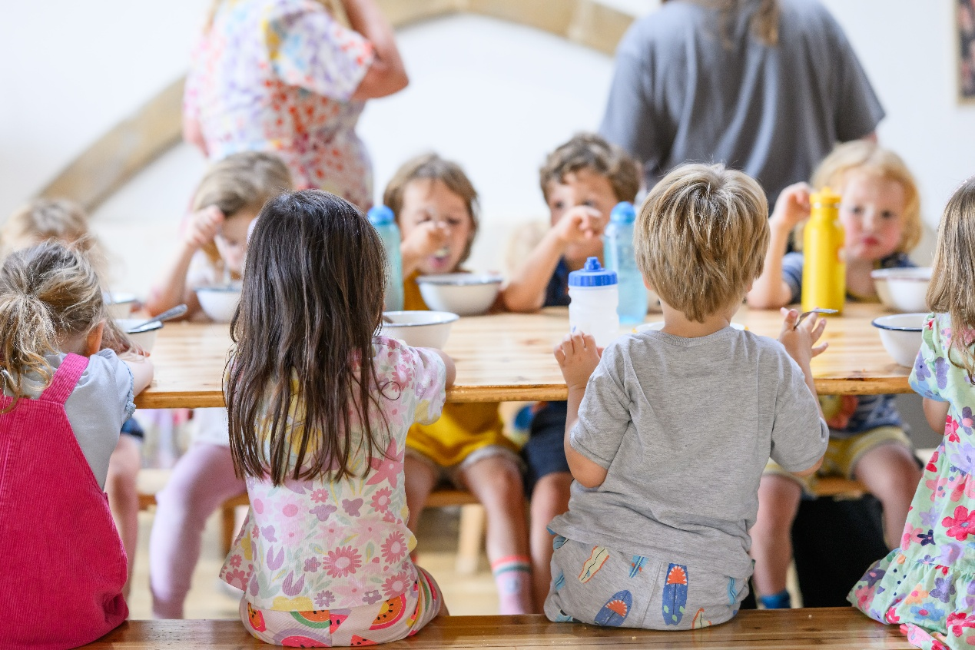

What to bring (and What not to bring)..

Please provide change of clothes and appropriate outdoor clothing.

Appropriate Outdoor Clothing for all Seasons:

- Fully Waterproof body suit (in both Summer and Winter)
- Sun hat (in Summer)
- Wellies/waterproof foot coverings for non-walkers (all year round)
- Warmer layers for colder weather, including warm jumpers, hats and gloves.

We will provide nappies, snacks, wipes and suncream (unless you prefer us to use a particular brand). Please note we can’t take responsibility for any toys or personal belongings that your child chooses to bring with them.

Please provide a clean drinking bottle filled with fresh water every day. Due to our healthy ethos, we do not allow children to drink juice from their bottles at Hippy Kids.

There is a buggy park at Playschool where you can leave your buggy/scooter/bike at your own risk.

Notice Period

During the first 4 weeks of our contract either party can terminate without notice. After this we will require 4 weeks notice to end or decrease hours in our contract if your child attends less than 20 hours a week. If your child attends more than 20 hours a week please provide 6 weeks notice. This may be negotiable if we have children on our waiting list.

Animal and Pet Policy

At Hippy Kids, we may occasionally have visits from our staff pets or sometimes ‘pet sit’ smaller animals such as hamsters and guinea Pigs. We feel that being around animals and nature is an enrichment for children and encourage this.

If the children have contact with the pets they are taught to treat the pets with respect. They learn how to handle the pets safely under careful and constant supervision. Children are taught to wash their hands thoroughly after handling pets.

Constant risk assessment ensure children are safe at Playschool and in the garden and when we meet other animals whilst we are on our adventures.

Toilet Training

At Hippy Kids we recognise and celebrate children when they reach the milestone of using the toilet. We use positive language and encouragement about this exciting stage.

We are always very happy to chat to parents and discuss a child’s stage of development in this area and we will share our views and advice. It is important to us that we do not set the expectations too high for children to achieve this stage too soon and that the whole experience is as smooth and successful as possible for them.

Please try to find the time to ask us our thoughts and explain your expectations so we can contribute our help before sending your child to Playschool without a nappy for the first time.

We will always offer our full support when it is agreed that a child is ready but we will also ask the following questions:

- Is your child beginning to recognise the sensation of needing to use the toilet?
- Can they independently verbalise their need to use the toilet?
- Is your child able to pull their clothes and underwear up and down?
- Are they beginning to be interested and able to help wipe themselves and wash their hands?
- Is your child able to use a step and independently sit on the toilet?

If the answer to any of those questions is no, then we are likely to suggest more encouragement and practice is needed at home to make the transition easier for your child.

We do not use pottys at Hippy Kids. All the many children over the years who have been through this stage have achieved toilet training without the need for a potty whilst in our care. We do not use pottys mainly because of hygiene reasons, but also because we feel that this is an unnecessary extra step for the whole experience. The children use a camping toilet in the forest garden which is very manageable and a step to the toilet inside.

We ask parents to please remember to set realistic expectations whilst your child is toilet training with us, and to understand that it may not be possible for us to exactly replicate how you have been preparing for this at home. We cannot have children walking around with bare bottoms! Please bear in mind that we have ratios to think about and lots of small people with lots of needs.

Please remember that it is to be expected for your child to have many more accidents at Playschool than they would at home whilst they are getting used to the new routine. We will need lots of spare changes of clothes during the early stages and will provide as much feedback as possible at pick up time

